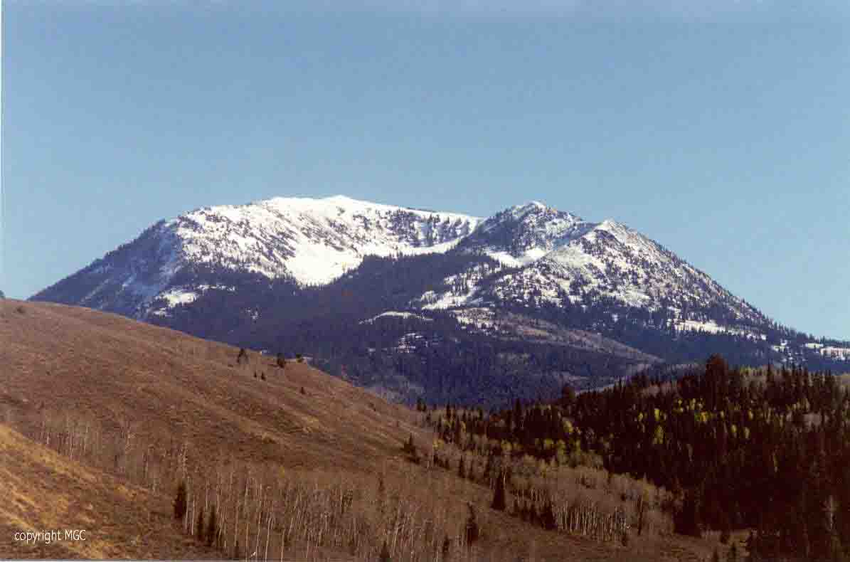

OWNER/OPERATOR
MICHAEL COMMONS
E-mail: Cariboo2002@msn.com
http://www.miningclaims.org
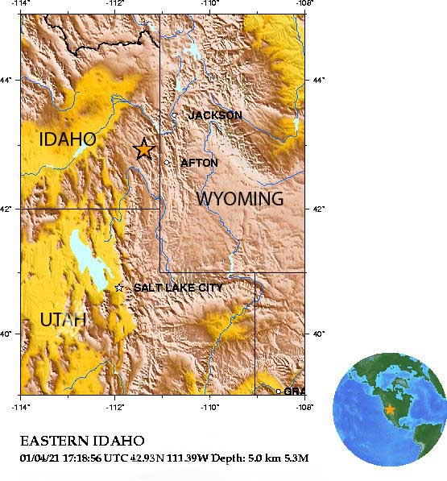

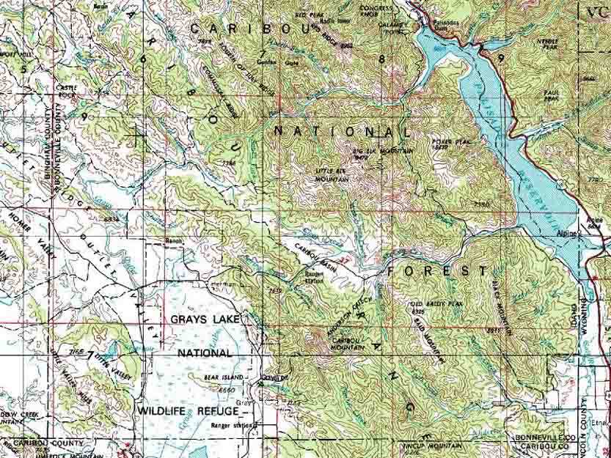

Figure 1

Caribou Mountain is located between Grays Lake and Palisades Reservoir, Bonneville County, Idaho as seen in Figure 1. It is about 20 miles from Alpine, Wyoming and approximately 50 miles from Jackson Hole, Wyoming.

Caribou got its name from a man by the name of Jesse Fairchilds; know as “Carriboo Jack”. He received this nickname being from the Carriboo mining district of British Columbia. Jesse Fairchilds, F. S. Babcock, John Keenan, and Frank McCoy are usually honored as having made the first gold discovery in 1870.

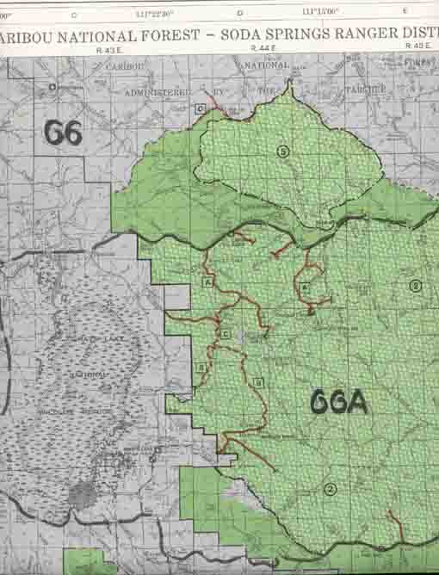

Figure 2

Above is a Caribou National Forest map with Caribou Mountain about in the center.

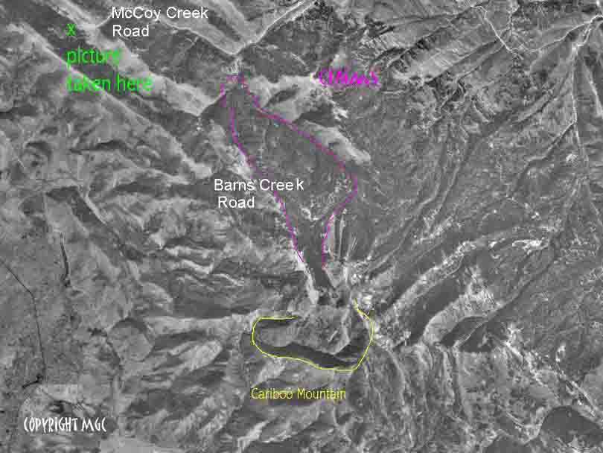

Figure 3

Above is an aerial photograph of Caribou Mountain. The yellow line outlines the top of the mountain. The purple line outlines the Commons claims. Glaciers created the cirque eroding north. This produced the materialization on the claims. The water for Barnes Creek originates from the cirque or the bowl.

At the bottom of the mountain (or the top of the picture) is the Keenan City site. The road at the top of the picture going east to west is McCoy Creek road. Alpine, Wyoming is only 20 miles to the east.

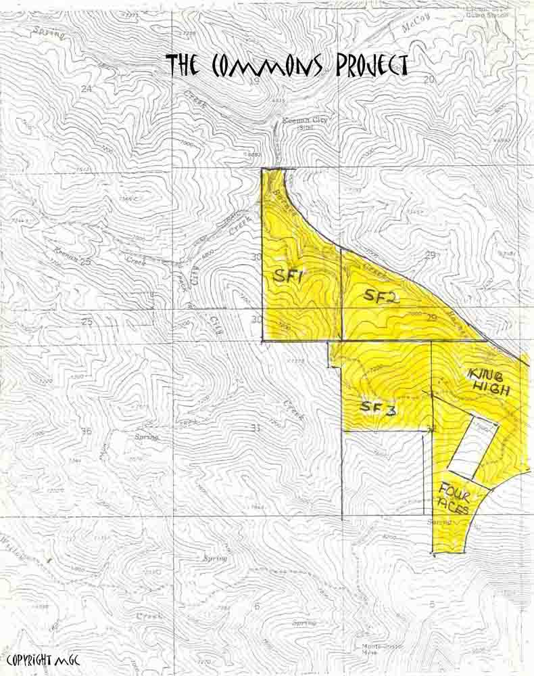

Figure 4

Above is a topography map outlining the general boarders of the Commons claims.

King High IMC 183410 160 acres
Sun Forsure 1 IMC 183411 160 acres
Sun Forsure 2 IMC 183412 160 acres
Sun Forsure 3 IMC 183413 160 acres
Four Aces IMC 183414 160 acres
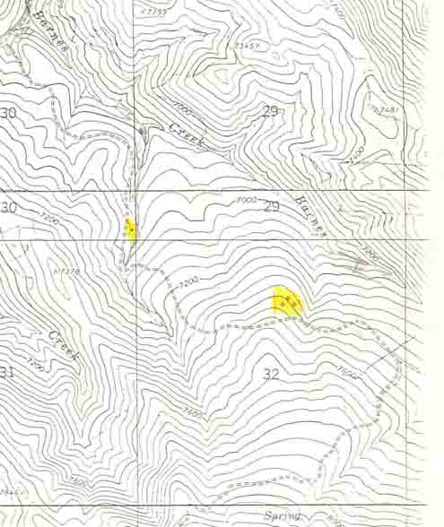

Figure 5

Highlighted in the above map are the cabins that still exist. These are wants left of old mining camps. The single cabin is the Charlie Barnes cabin.
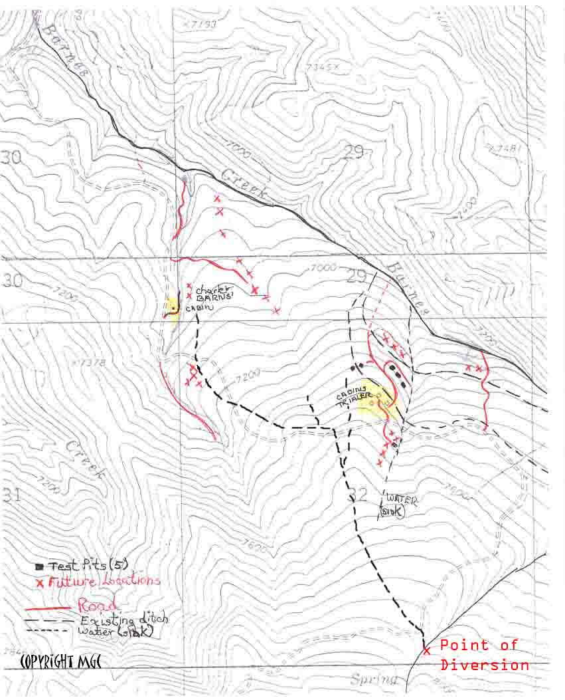

Figure 6
This area of the mountain has an entire ditch system already intact. Sections of the ditch have had constant maintenance and the rest can be opened fairly easily. The main Point of Divergence, seen in the lower right hand corner of Figure 6, has NOT had more than seven years of nonuse and has water running now. Any mining operation can be totally gravity fed.

Barnes Creek road has existed since the 1870’s (RS 2477).

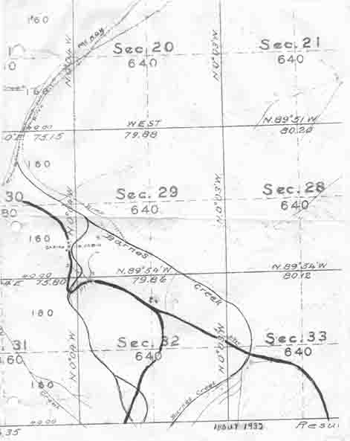

Figure 7

Figure 7 is a map from the 1930’s. Note the existence of the roads, cabins sites and ditches.

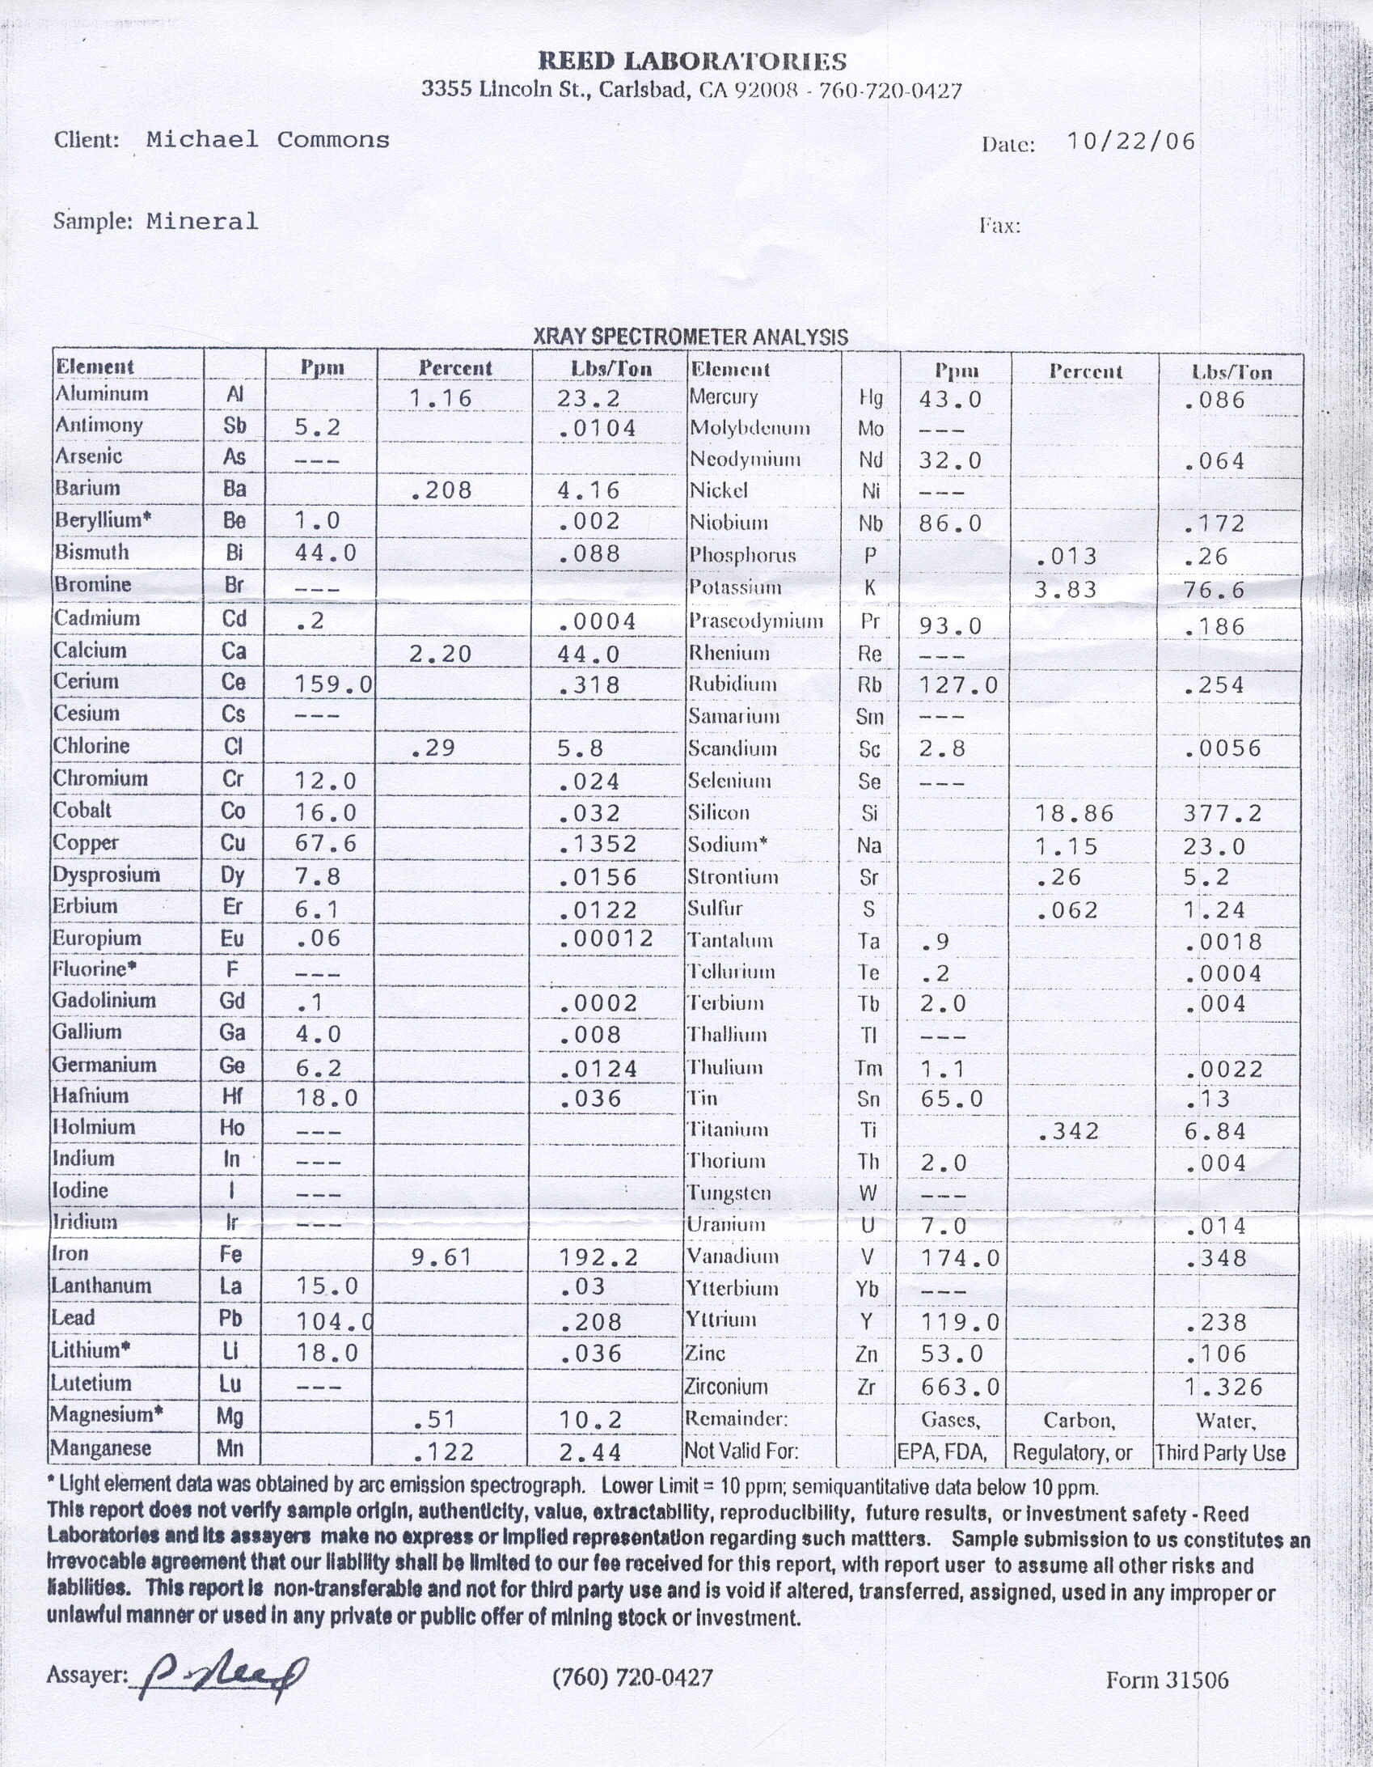

Figure 8

Figure 8 is an assay of some of the rock that is prevalent. There is a very large amount of this rock and a lot of it sets in piles miles long. This assay does not include gold, silver or the platinum groups.
ADVANTAGES

1: Sole owned five 160-acre claims

2: An entire ditch system already established.

3: Roads already established.

4: Cariboo Mountain has some of the purest gold.
Also contains:
- Silver
- Rare earths
- Platinum groups

5: Oil companies have drilled all around Grays Lake and in the early 1980’s there was a very large complex built on the next ridge near the Caribou City. British Petroleum Inc. has interests in the area.

6: Under the Marketability Act any minerals that are not locatable can be marketed.
- Rock
- Clay
- Pumas
- Gravel

7: There is large amount of lumber and rock on the claims.
- Health Forest Initiative
- 1872 mining laws
- 1892 Building Stone Act
A: United States v. United Mining Corporation

8: Can be subdivided to any size.
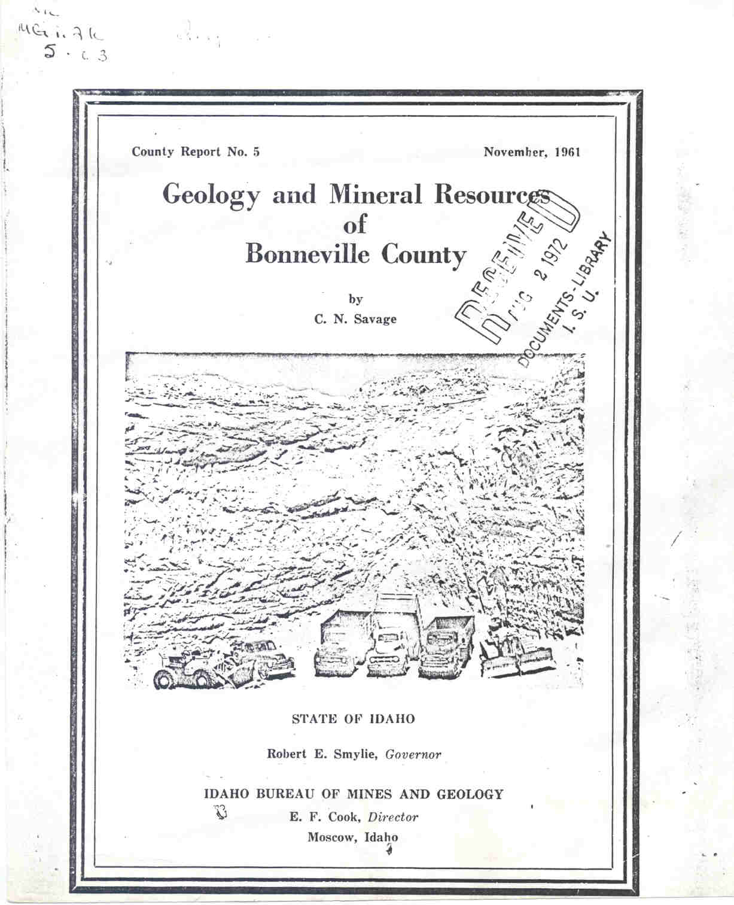

The following is from the “Geology and Mineral Resources of Bonneville County” report of 1961: Other minerals on Cariboo Mountain.



